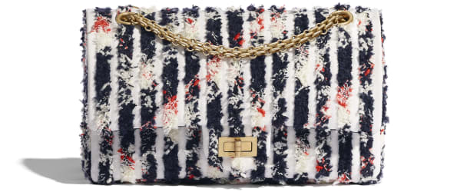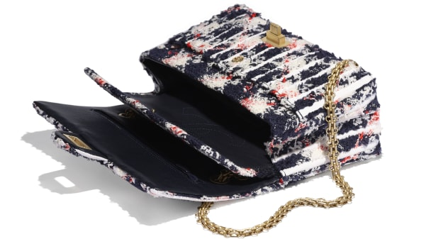

Wool Tweed, Denim & Gold-Tone Metal

Ecru, Navy Blue, Orange & White

16 × 24 × 7.5 cmin

Reference: A37586 B01467 N5259

**CAN$6,825**